>
>
slabye i silnye razryvy reshenii nelineinyh uravnenii
Bissengaliyeva Assem mkm

> restart:
> with (plots);
Warning, the name changecoords has been redefined

vvod ishodnyh dannyh
F(u)=cos(u), u0(x)=sin(x)

> F:=u->cos(u);
> u0:=x->sin(x);
решение уравнения u-u0(x-F'(u)*t)=0 при t=0
> implicitplot(u-u0(x), x=-1..1,u=-1..1);
rewenie uravneniya u-u0(x-F(u)*t)=0 при t=0.2
>
> implicitplot(u-u0(x-diff(F(u),u)*0.2), x=-1..1,u=-1..1);
> C:=implicitplot((u-u0(x)=0, x=-1..1,u=-1..1),style=line, color=blue):
> E1:=implicitplot((u-u0(x-diff(F(u),u)*0.1)=0, x=-1..1,u=-1..1),style=line,color=blue):
> E2:=implicitplot((u-u0(x-diff(F(u),u)*0.2)=0, x=-1..1,u=-1..1),style=line,color=red):
> E3:=implicitplot((u-u0(x-diff(F(u),u)*0.3)=0, x=-1..1,u=-1..1),style=line,color=green):
> E4:=implicitplot((u-u0(x-diff(F(u),u)*0.4)=0, x=-1..1,u=-1..1),style=line,color=violet):
> E5:=implicitplot((u-u0(x-diff(F(u),u)*0.5)=0, x=-1..1,u=-1..1),style=line,color=blue):
> E6:=implicitplot((u-u0(x-diff(F(u),u)*0.6)=0, x=-1..1,u=-1..1),style=line,color=blue):
> E7:=implicitplot((u-u0(x-diff(F(u),u)*0.7)=0, x=-1..1,u=-1..1),style=line,color=blue):
> E8:=implicitplot((u-u0(x-diff(F(u),u)*0.8)=0, x=-1..1,u=-1..1),style=line,color=blue):
> E9:=implicitplot((u-u0(x-diff(F(u),u)*0.9)=0, x=-1..1,u=-1..1),style=line,color=blue):
> display((C,E1,E2,E3,E4,E5,E6,E7,E8,E9),axes=boxed,scaling=constrained,title='Uravnenie');
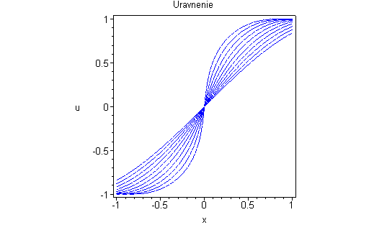
> animate( u-u0(x), x=-1..1,u=-1..1,frames=50);
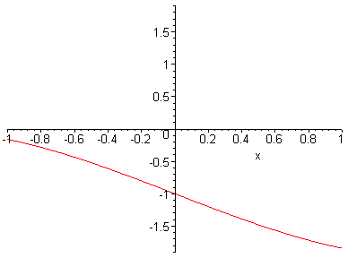
> animate( [u-u0(x-diff(F(u),u)*t, x=-1..1],u=-1..1,t=0..1, frames=50);
Error, `]` unexpected

>

